**Data Driven testing**

1. **What is Data driven testing?**

Read the data from external recourse & run the test is called Data driven testing (parameterization)

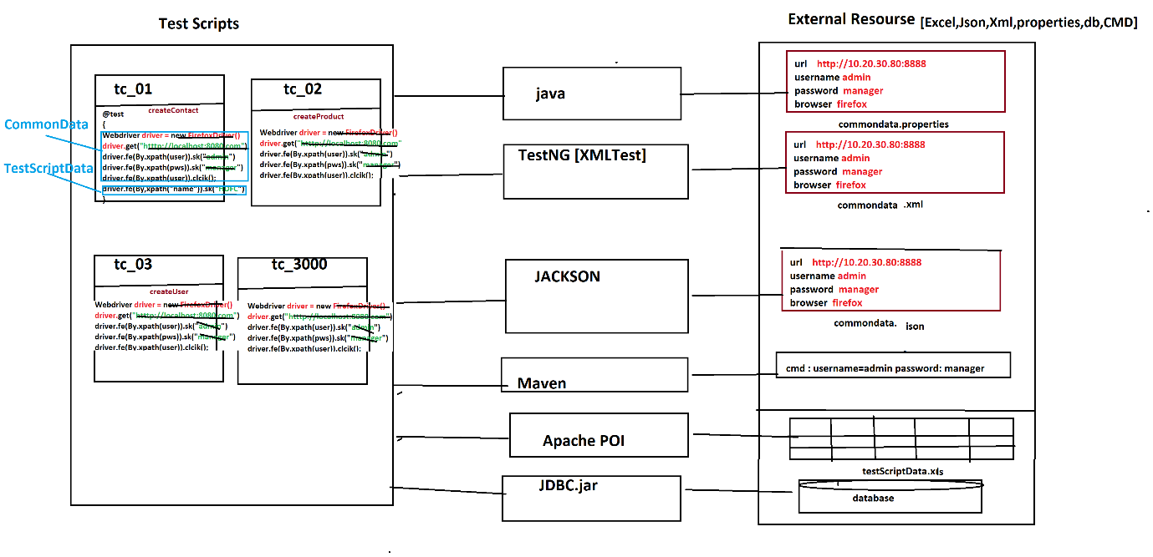

1. Why Data Driven testing?

As per the rule of the automation data shouldn’t not hardcoded(fixed) with in a test scripts, because data modification & maintenance is tedious job when you want to run the test with different data, instead we should get the data from external resource like xlsx, .properties file , db , XML, JSON, CMD Line Data

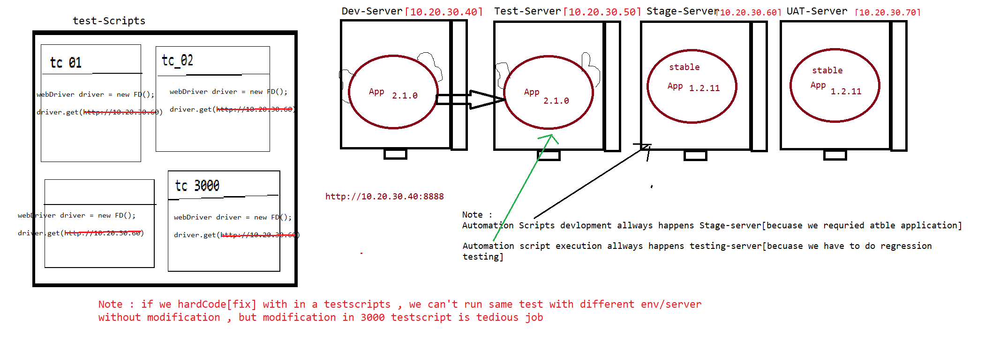

1. What is Advantages of Data driven testing
2. Maintenance of the test data is easy
3. Modification of the test data in external recourse is easy
4. Cross browser /platform testing is easy (means change the browser in property File)
5. Running test scripts in different Environment is easy
6. Running test scripts in different credentials is easy
7. We can create the test data prior the Suite execution (we can also get the data from testData team)
8. Rerunning same test Script with multiple time with different data is easy

**Data driven testing from Properties File**

1. **What is Properties File?**

Properties is java feature file where we can store the data in from of key & values pair,

Key & value data type should be always string .

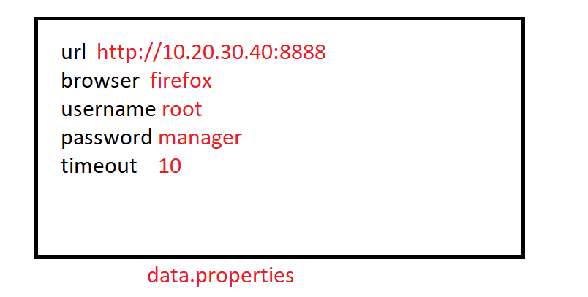

1. **Why Property file ?**

Property file is light weight & faster to read the data compare to any other file , & java as own Class to read the data from property

1. **How to read data from properties File?**

* Get the java representation Object of the Physical file using “FileInputSteam
* Create a Object of “Properties” class & load all the keys
* Read the data using getProperty(“Key”)

Note : properties file light weight & faster in execution compare to Excel

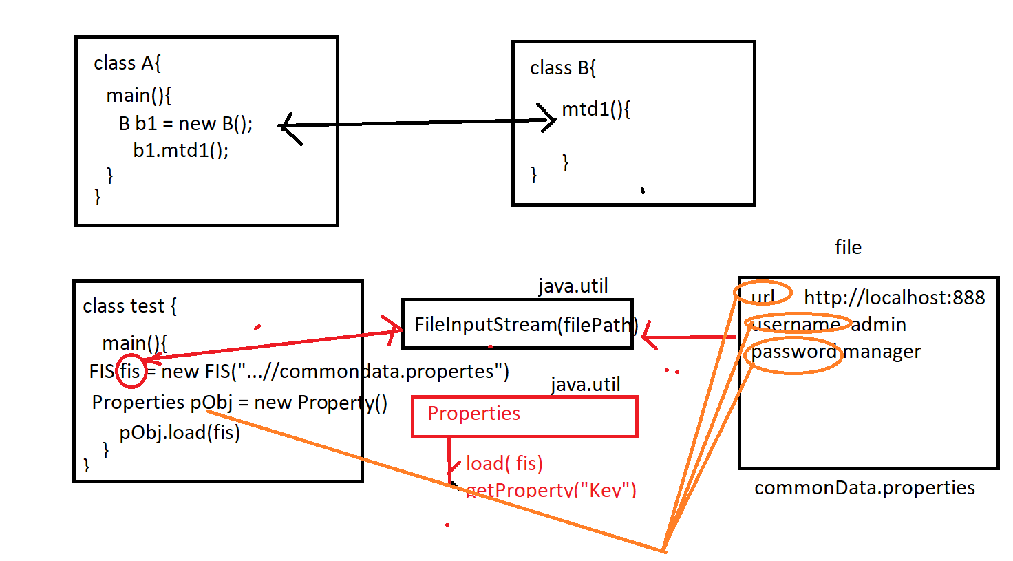

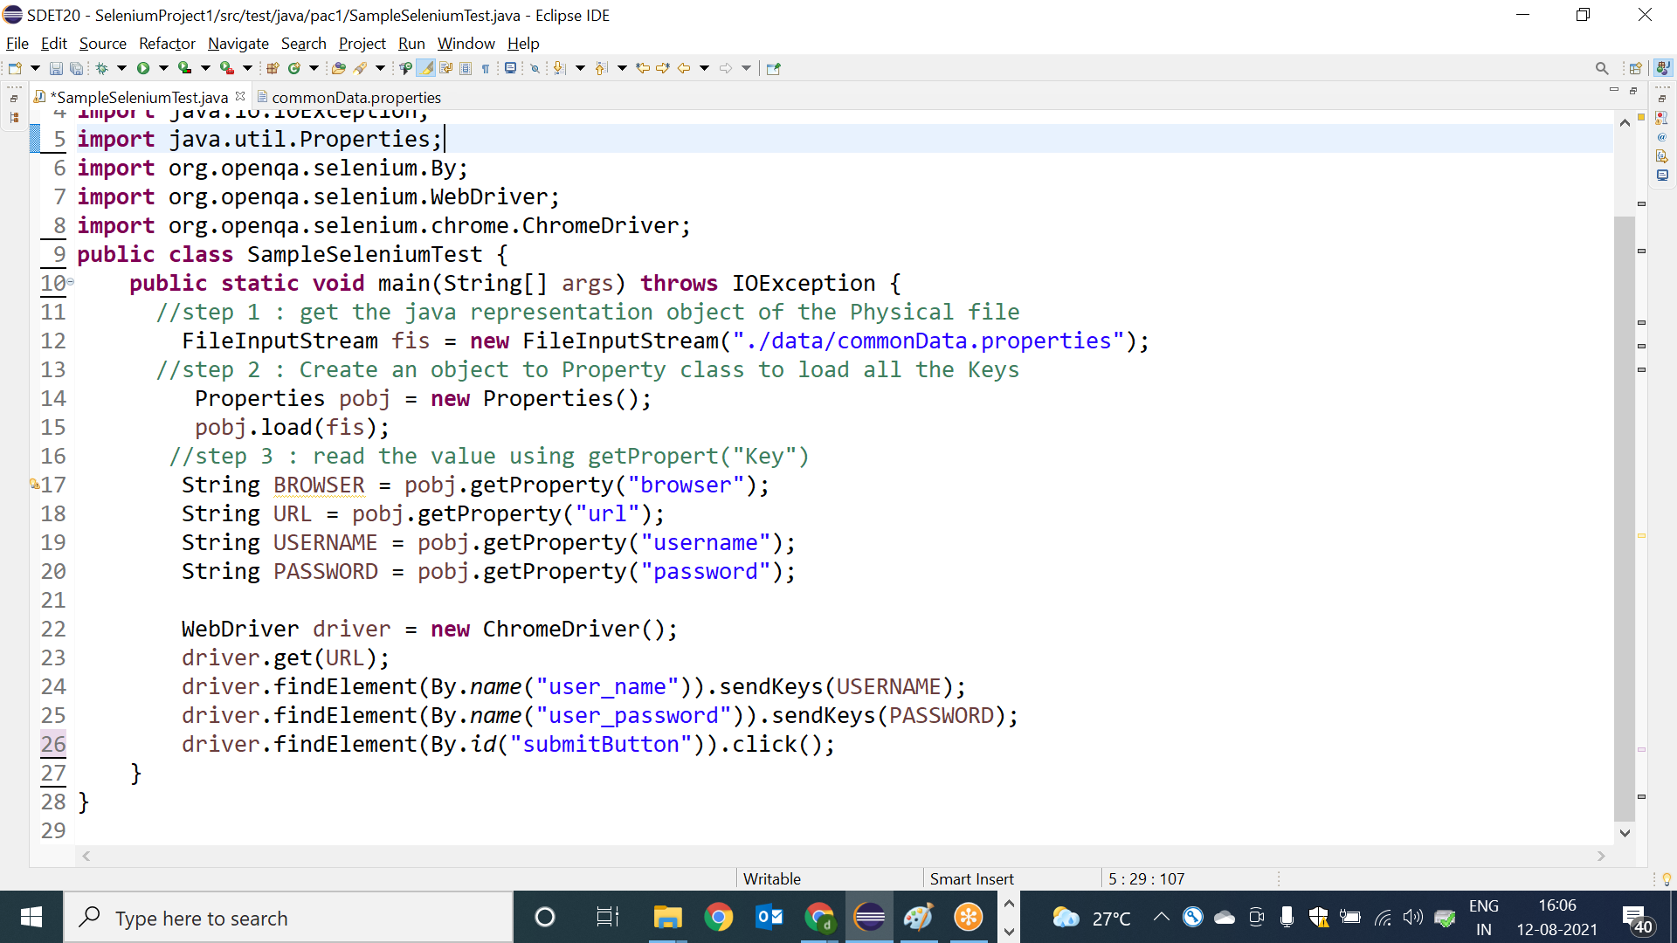

**How to use Browser data in Seleniumtest**

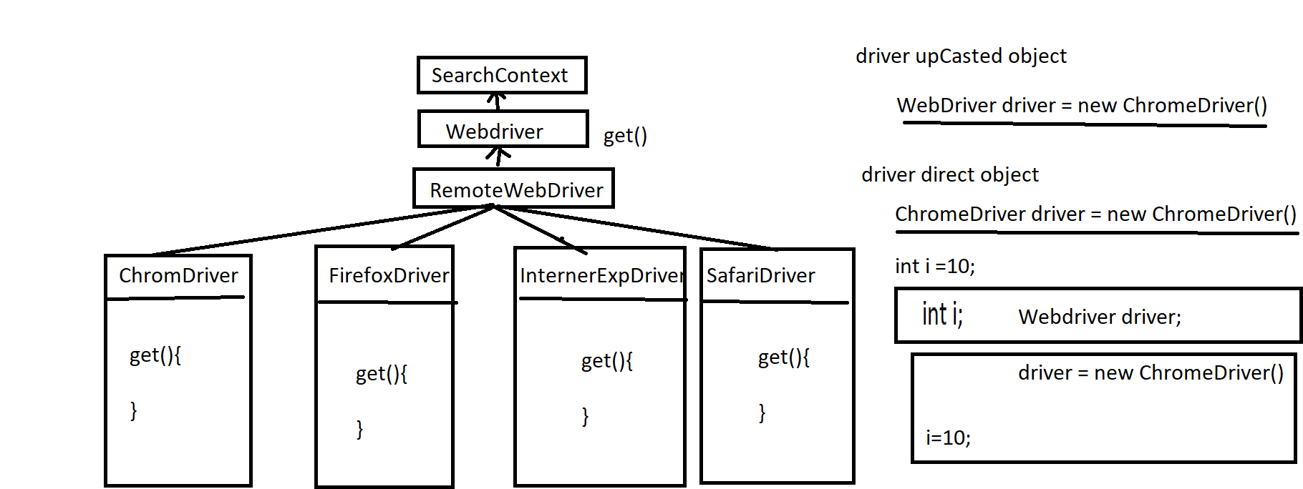

EG : best example for run time Polymorphism , driver object behave differently in run time

Assignment:

Test Case : CreateOrganization

step 1 : login

step 2 : navigate to Organization module

step 3 : click on "create Organization" Button

step 4 : enter all the details & create new Organization

step 5 : verify Organization name in header of the msg

step 6 : logout

Note :

1. Any data should not be hardcoded
2. test should able to run in different browser with minimal changes
3. test script data should get it from EXCEL sheet

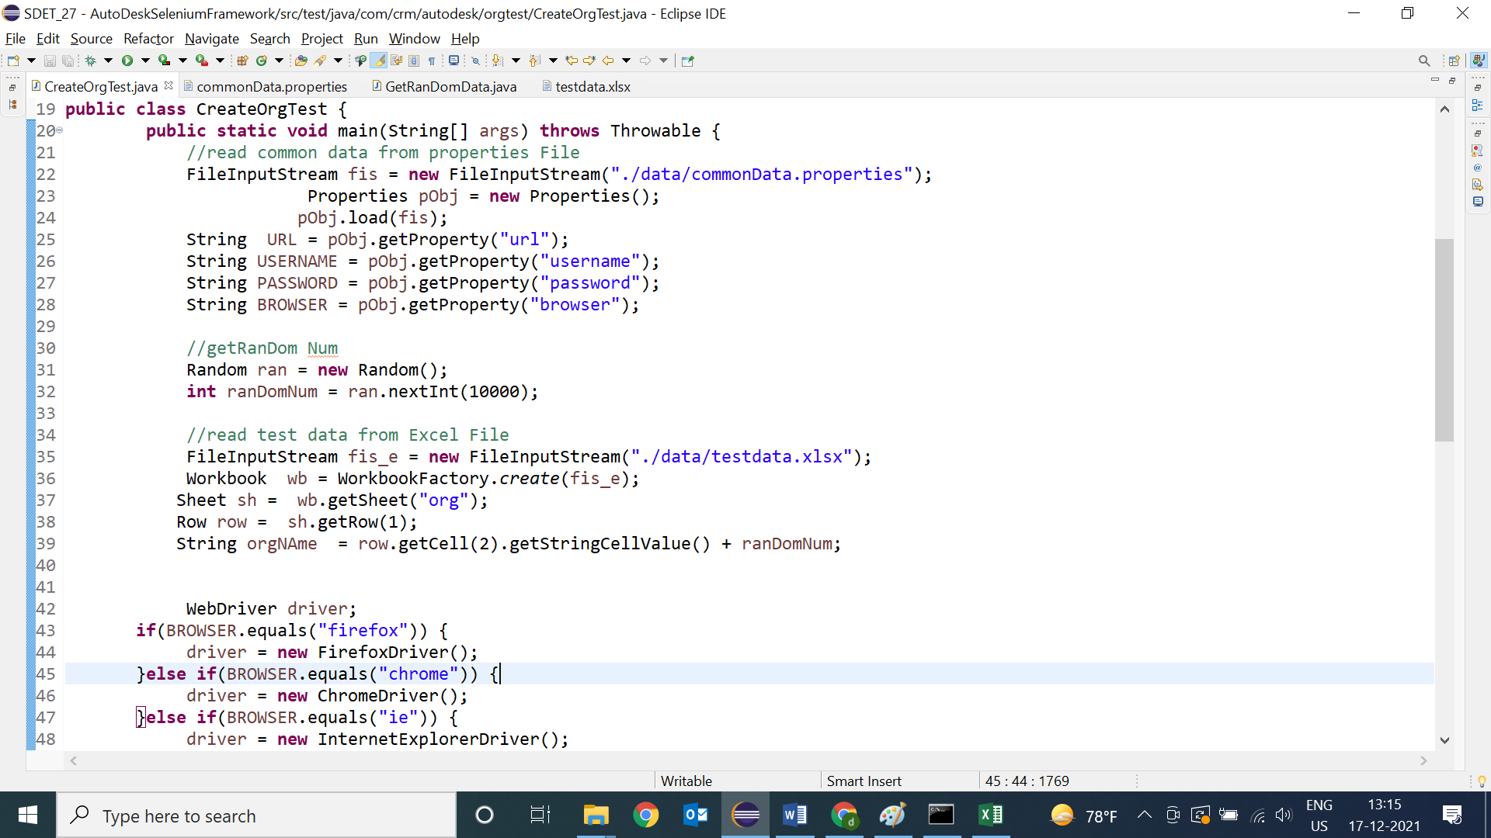

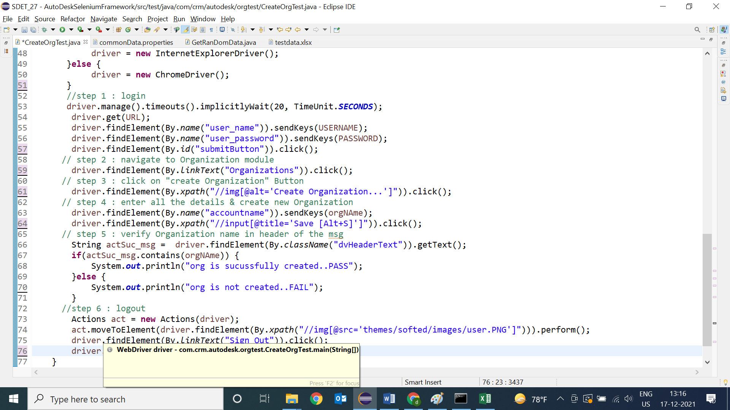

**Data driven testing from Excel File**

🡺Apache Poi is the open source libraries used to get & write data from all Microsoft documents like Excel , docx , ppt etc

🡺In real time most the company preferred the keep the test script data in Excel, because data will be in well-organized manner , so that modification & maintenance is easier.

Installation steps:

1. Go the Maven Project
2. Edit POM.xml file
3. Go to <https://mavenrepository.com>
4. Search for apache-POI
5. Copy the dependency
6. Add dependency inside the <dependencies> in POM.xml

<dependency>

<groupId>org.apache.poi</groupId>

<artifactId>poi</artifactId>

<version>4.0.0</version>

</dependency>

<dependency>

<groupId>org.apache.poi</groupId>

<artifactId>poi-ooxml</artifactId>

<version>4.0.0</version>

</dependency>

Class diagram of Apache POI

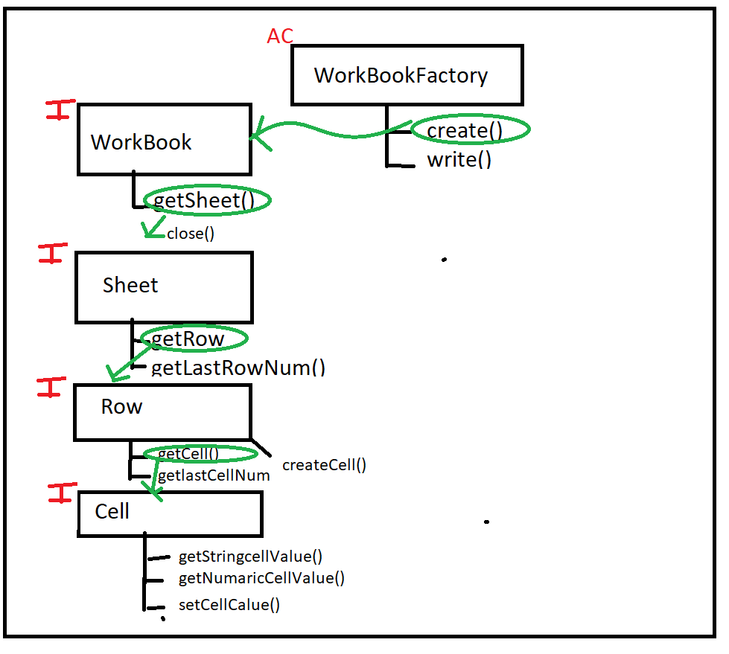

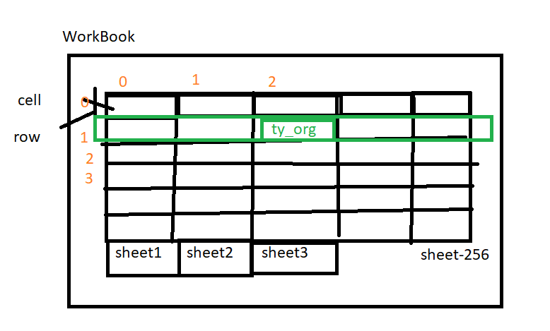

1. Program to read the data from WorkBook

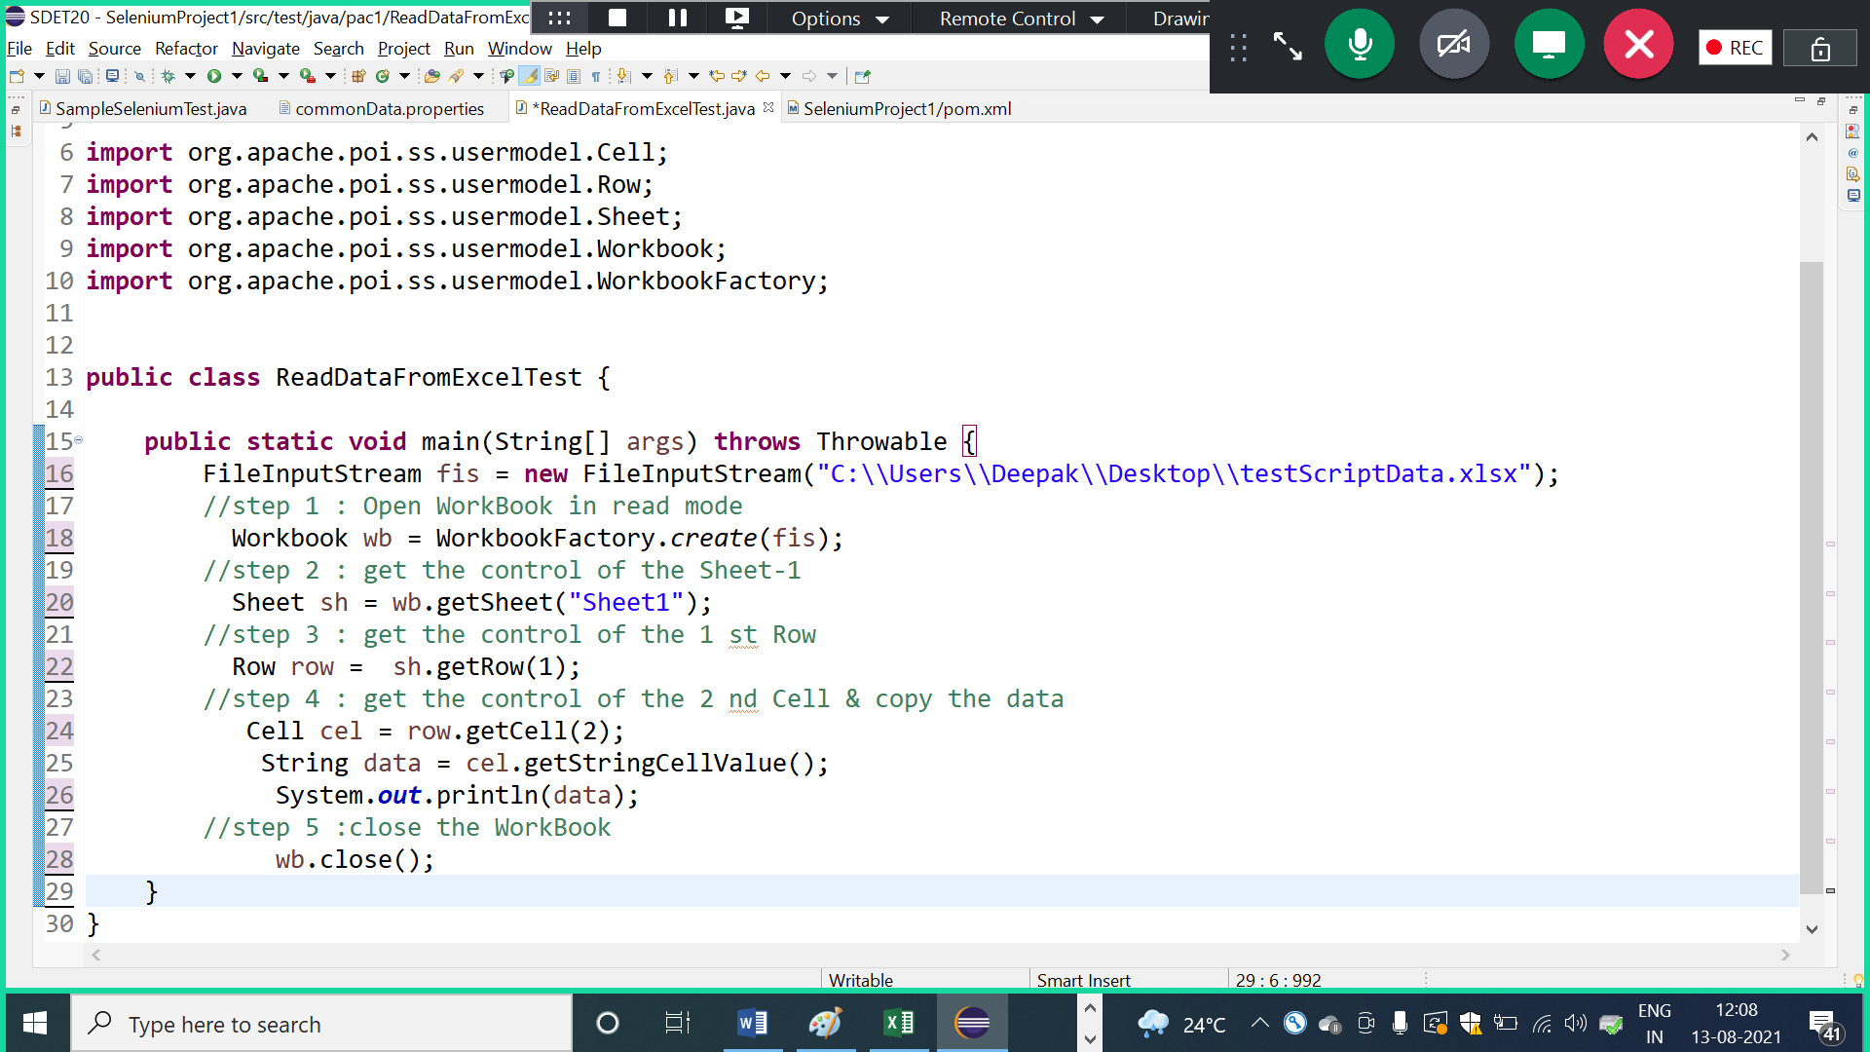

1. Program to read 1 st & 2 nd coloum data from all the Rows

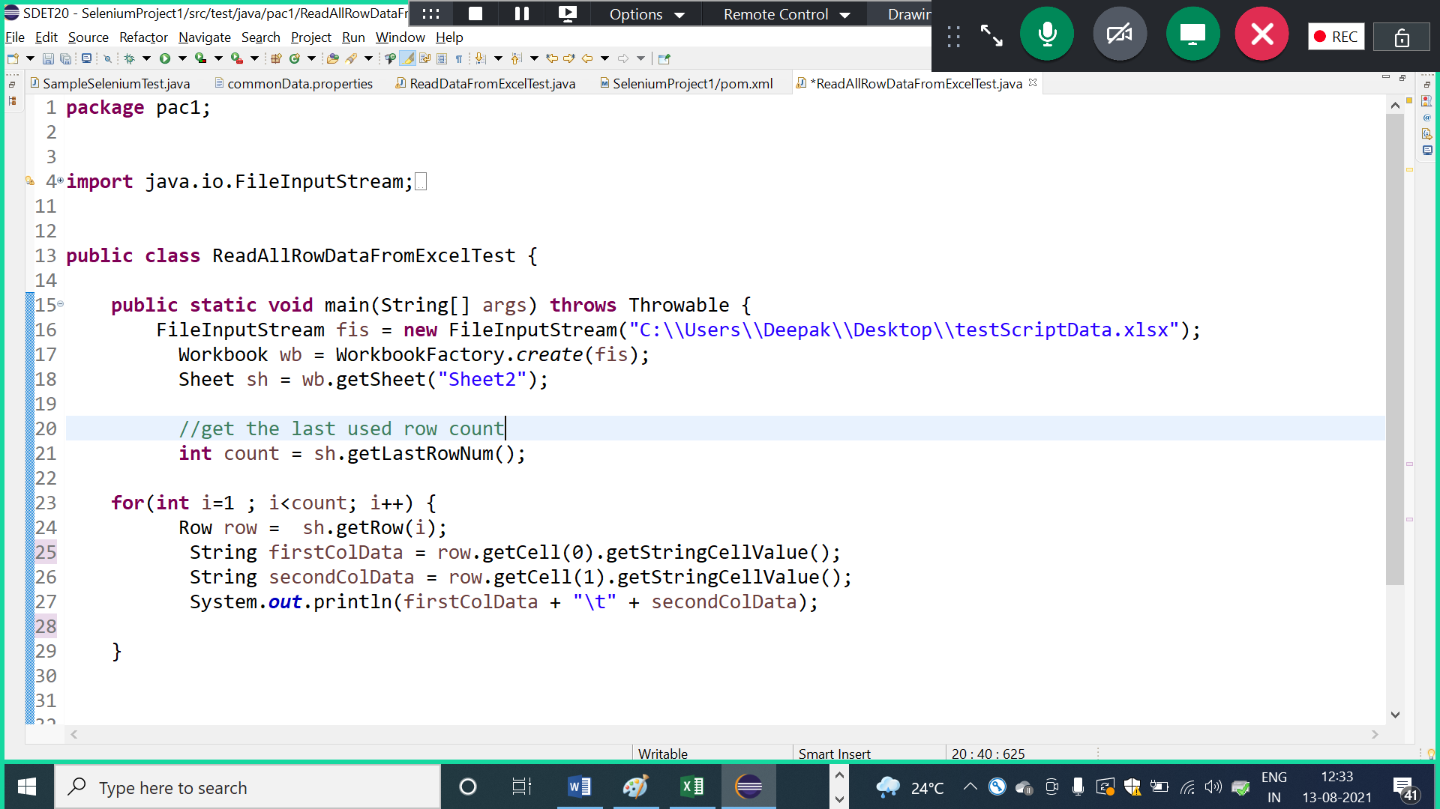

1. Write a program to find specific data from 1 st column , if data is available then read & dispaly next cell data

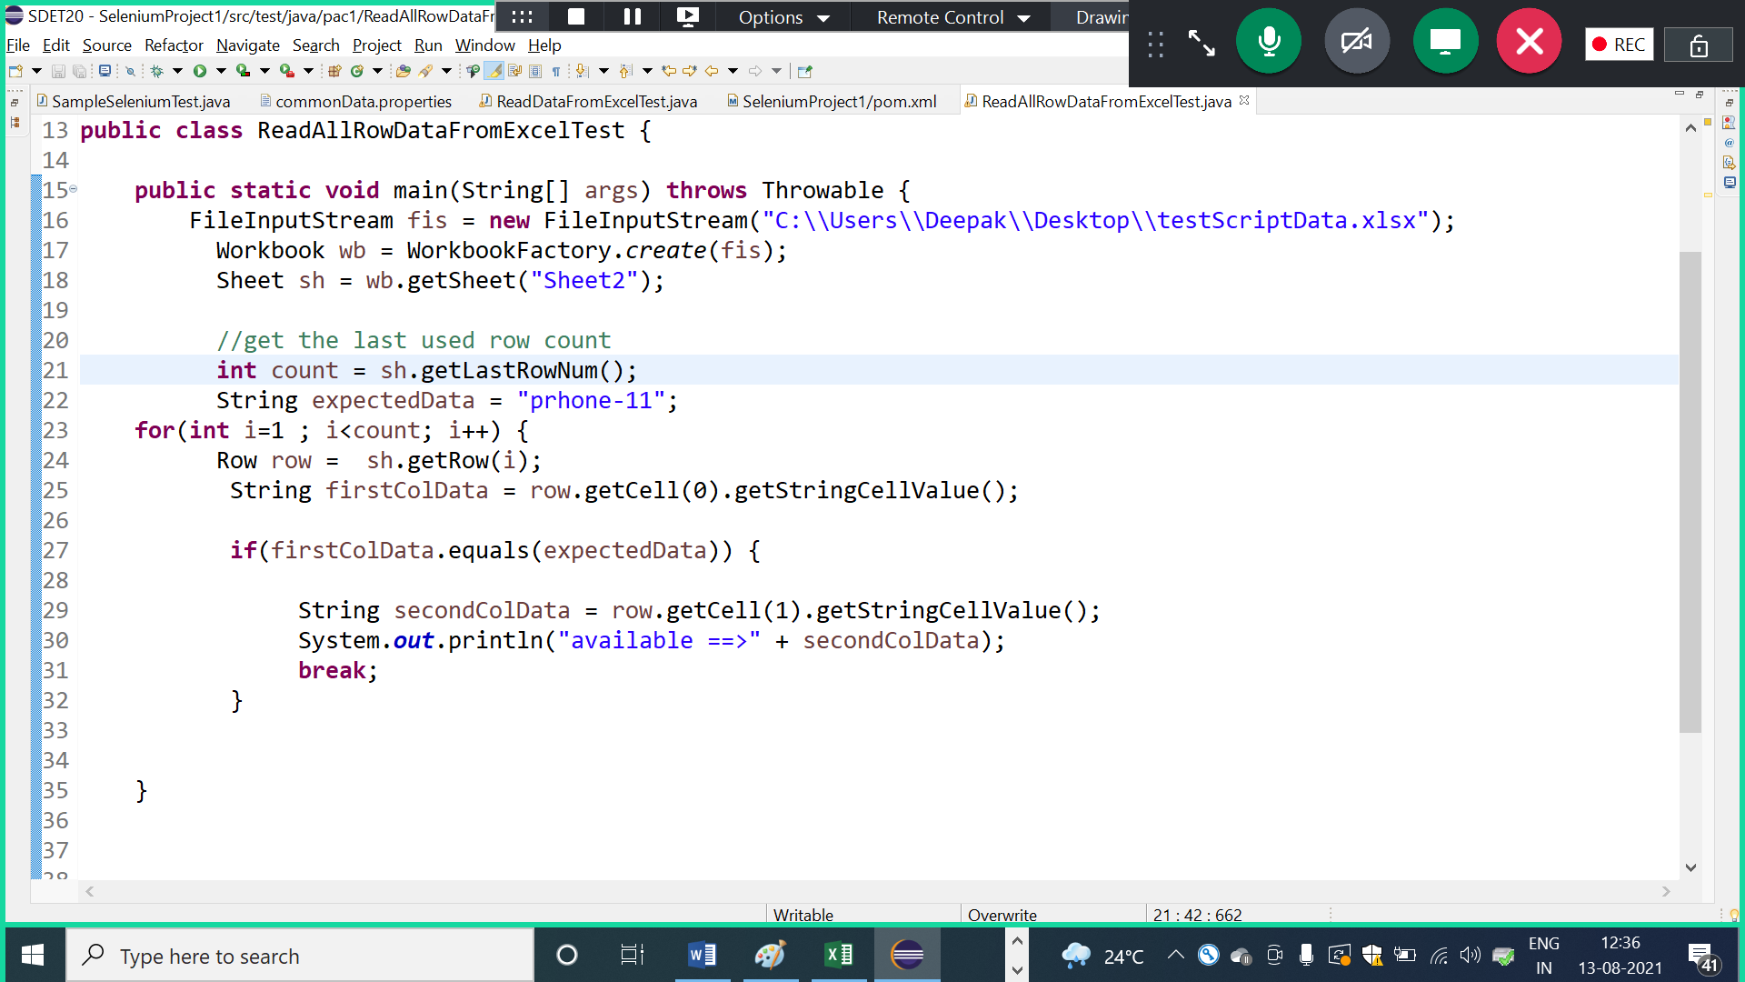

1. Program to write data back to WorkBook/ Excel

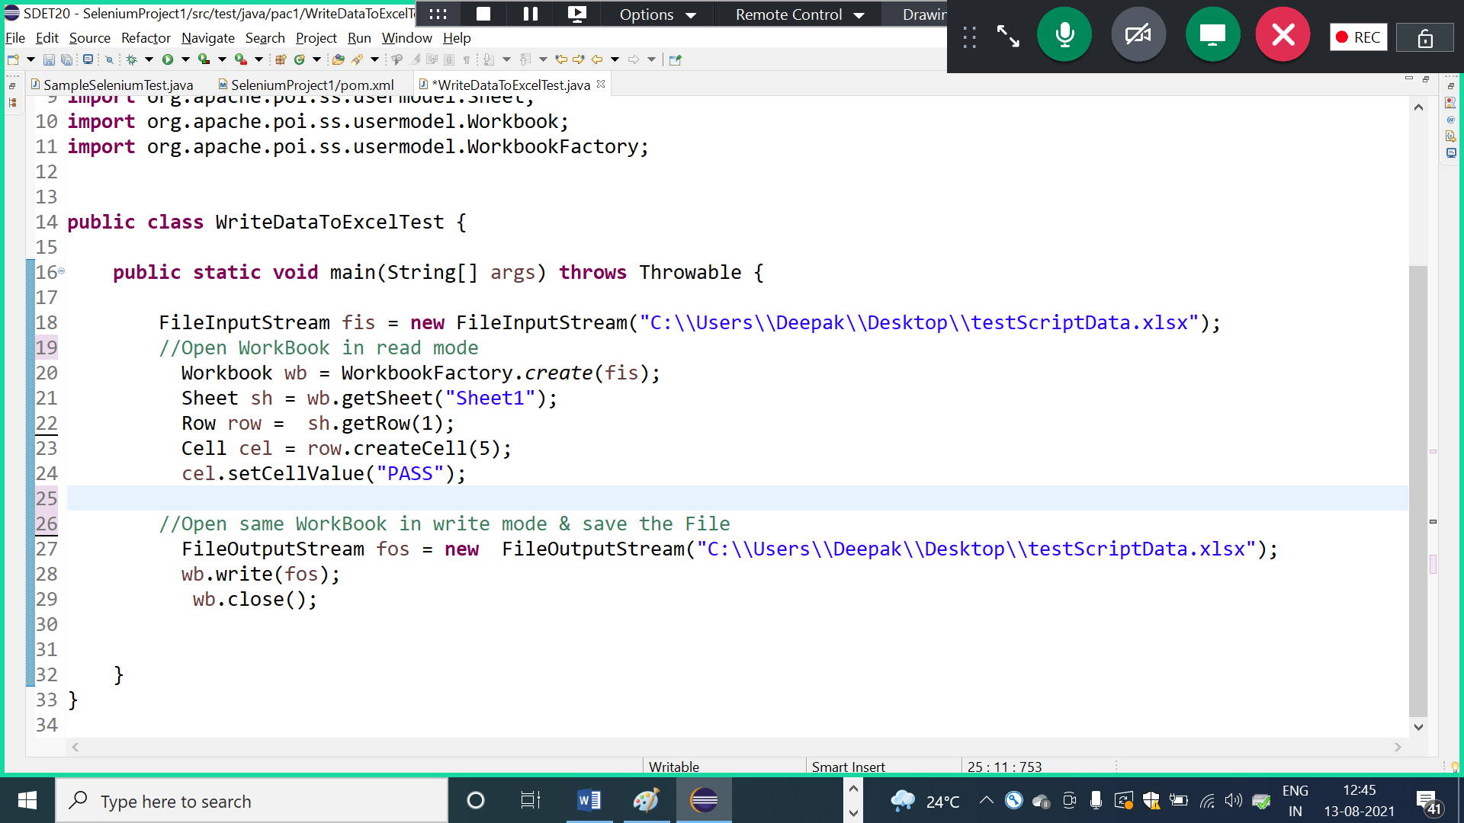

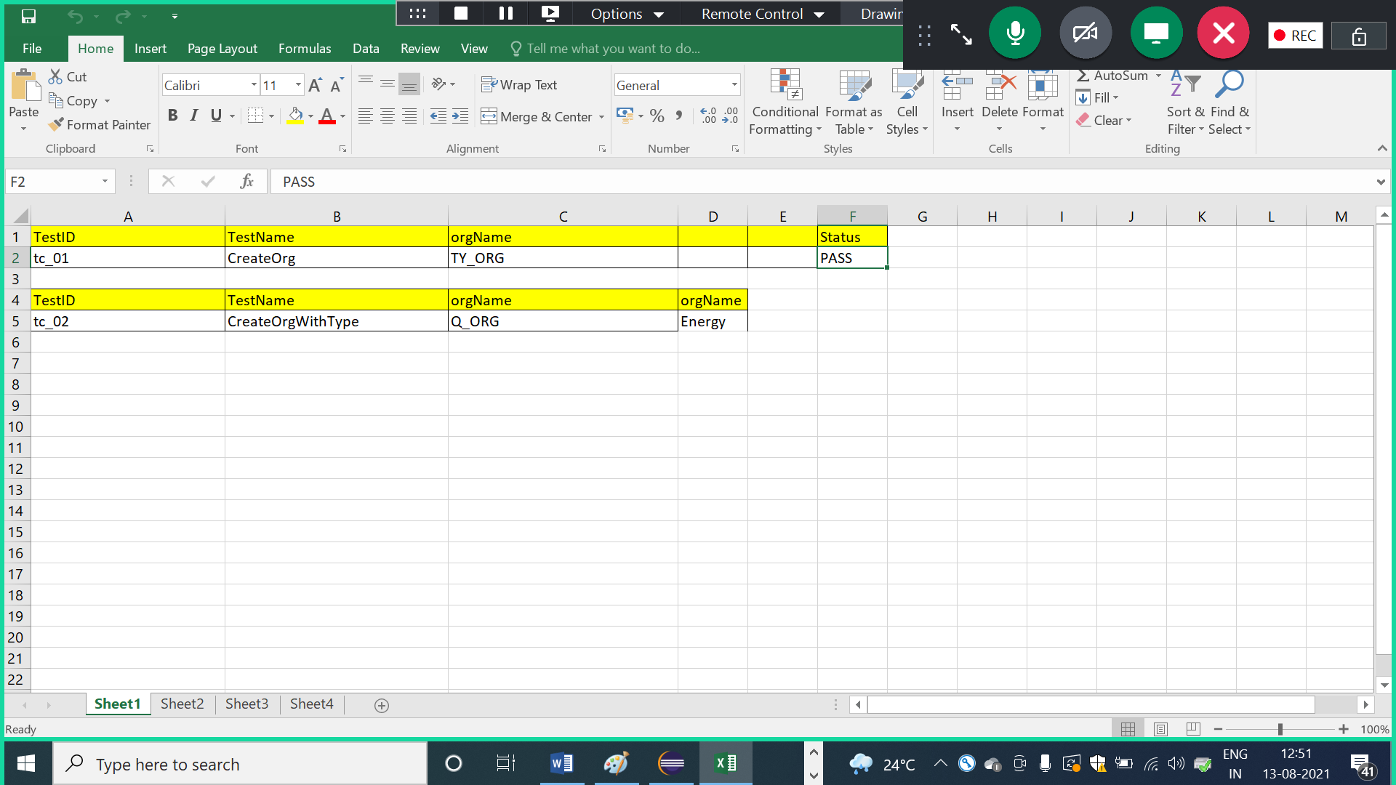

How to generate random number using java

